

**Quantitative Easing: An Interim Report**

Speech given by

Charles Bean, Deputy Governor for Monetary Policy, Bank of England

At the London Society of Chartered Accountants Annual Lunch, London 13 October 2009

1

All speeches are available online at [www.bankofengland.co.uk/publications/Pages/speeches/default.aspx](http://www.bankofengland.co.uk/publications/Pages/speeches/default.aspx)

It’s a great pleasure to be invited to speak to you this afternoon.

It is almost exactly a year since Lehman Brothers collapsed, precipitating a near-fatal heart attack for the global financial system. And in its wake came an unprecedentedly sharp and synchronised contraction in global economic activity, from which we are only just starting to emerge. In part, that stabilisation reflects the intensity of the countervailing policy actions by governments and central banks around the world.

Injections of capital, funding guarantees, ring-fencing of toxic assets and abundant liquidity support have helped to return the banking system towards normality, though the process of balance-sheet repair still has some way to go. And substantial increases in fiscal deficits and aggressively expansionary monetary policies have helped to arrest the fall in spending, output and employment.

For its part, the Bank of England’s Monetary Policy Committee not only cut Bank Rate from 5% in September last year to just 0.5% in February, but also embarked on a programme of large scale asset purchases financed by the issuance of extra reserves – so-called ‘Quantitative Easing’. This unlovely phrase was originally coined to describe a related policy conducted by the Bank of Japan in the early part of this decade and has perhaps lost something in the translation. But sadly it is a phrase that we are now well and truly stuck with.

Like a lot of our operations, Quantitative Easing can seem a bit mysterious and confusing to those not steeped in what central banks do. As much of this confusion arises from a misunderstanding of the Bank of England’s accounts, I am therefore delighted to be speaking to an audience of accountants, who might find this arcane subject rather exciting!

In January this year, the Chancellor authorised the Bank to create a new fund – the Asset Purchase Facility – for the purpose of buying assets from the private sector. Any profits on the Asset Purchase Facility are passed to Her Majesty’s Treasury, while any losses are also indemnified by the Exchequer. The accounts are therefore not consolidated with the Bank’s own accounts, as the Bank has no economic interest in the fund.

Initially, the Facility purchased commercial paper, funded by the proceeds of sales of short-term Treasury bills by the Debt Management Office. This asset swap took credit risk onto the public sector’s balance sheet and was therefore more akin to a fiscal operation. But since March, purchases have been on a much larger scale and funded through the issuance of central bank reserves rather than Treasury bills. The bulk of the purchases have been of government bonds, though a small quantity of investment-grade corporate bonds have also been bought. So far, about £164 billion of assets have been purchased in this way, as against the Monetary Policy Committee’s current target of £175 billion. To put that in perspective, £175 billion represents roughly 12% of annual GDP.

Technically what happens is the following. The Asset Purchase Facility buys assets funded by a loan from the Bank. In turn, the Bank funds that loan through additional reserve creation (Chart 1). If this sounds like financial alchemy, consider how the money flows through the system. When the Asset Purchase Facility buys a gilt from a pension fund, say, it can be thought of as paying with a cheque drawn on the Bank of England. The pension fund will then bank the cheque with its own commercial bank, so the latter now has a claim on the Bank of England – that is what reserves are. In reality, these payments are not made by cheque, but rather are carried out electronically. But the principle is the same, though one key difference is that we pay Bank Rate to the commercial bank on its claim on us, as well as charging Bank Rate on the loan we make to the Asset Purchase Facility.

Now I can add detours for the money at any point in this cycle. For example, the pension fund that sold the gilt to the Asset Purchase Facility might now withdraw its deposit and use it to purchase a newly issued corporate bond. The company issuing the bond then deposits that money in their own bank. So now it is the corporate’s bank that holds the claim on us. A similar sort of circle occurs if the corporate then uses its deposit to buy a new piece of machinery, because the seller of that machinery will end up putting the proceeds into her bank, so that the claim on the Bank of England is now held by the capital goods producer’s bank. Whatever the type of

purchase, it will always end up with someone’s commercial bank having a claim on us. That is even the case if the money is used to buy foreign goods, as the foreign commercial bank will need to exchange the sterling claim with a commercial bank that holds an account with us, if it does not do so itself. The only way that the claim can be eliminated from the system is if a bank chooses to exchange it for cash, which would make little sense since cash pays no interest at all.

The reason for going through this in such mind-numbing detail is to make the point that the level of commercial banks’ reserves *in aggregate* is determined by the way we have funded the asset purchases, not by the commercial banks’ own decisions. The size of banks’ reserves cannot, as is frequently claimed, be a sign that they are “sitting on them”. No matter how rapidly or how slowly the economy is growing, or how fast or slow the money is circulating, the aggregate amount of reserves will be exactly the same. So it should be clear that the quantity of central bank reserves held by the commercial banks is useless as an indicator of the effectiveness of Quantitative Easing.

Now obviously we would prefer that the money circulates more rapidly and that this is done through increased bank lending and deposit taking. In other words, we would like to see a further expansion of credit and broad money. Since the banks collectively are now awash with reserves, they should not be prevented from making additional loans because of any liquidity concerns. Banks are, though, constrained by a lack of capital and are looking to reduce leverage rather than increase it.

Fortunately, increased bank lending is not necessary for Quantitative Easing to work. Indeed, it was precisely because the Monetary Policy Committee expected the additional monetary injection not to stimulate bank lending directly at the current juncture, that the Asset Purchase Facility’s purchases were targeted at assets held primarily by the non-bank private sector1. So if the Asset Purchase Facility buys gilts

1 That is in contrast to the related policy conducted by the Bank of Japan in the early part of this decade, which was instead directed at purchases of Japanese government debt held by the banking sector.

from pension funds or asset managers, they will then have to look for another home for their money. As it is not very rewarding just to hold it on deposit, they are likely to look to put their money into other assets, including equities and corporate bonds. Thus not only does the price of gilts rise as a consequence of the Asset Purchase Facility’s initial purchases, but also the prices of a whole spectrum of other assets.

That in turn lowers the cost of non-bank finance and encourages increased corporate issuance. Also the rise in asset prices increases wealth and improves balance sheets. In this way, Quantitative Easing helps to work around the blockage created by a banking system that is still undergoing a process of balance sheet repair.

That is exactly what we have seen since the Monetary Policy Committee started its asset purchase program. Gilt yields fell sharply, though they have subsequently risen and fallen again (Chart 2). But gilt yields can move for a variety of reasons, including changing expectations of future interest rates. If we control for that by comparing gilt yields with a measure of market expectations of the future level of Bank Rate (Overnight Indexed Swap rates for an equivalent maturity), we find that this spread has fallen by around ¾ percentage point (Chart 3). Moreover, no such movement is observed in either the United States or euro area, which strongly suggests that the movement may be related to our gilt purchases2. More importantly for the real economy, sterling investment-grade corporate bond spreads have fallen over three and a half percentage points since the start of Quantitative Easing (Chart 4). And equity prices have risen by almost a half, the fifth largest increase in a six-month period over the past three hundred years (Chart 5). Accompanying this, UK companies have issued over £60 billion worth of bonds and equities since January, compared with an annual average of around £40 billion in recent years (Chart 6). Moreover, the spread between the three-month interbank rate over expected Bank Rate, which had been unusually elevated during the crisis, particularly after the collapse of Lehman Brothers, has fallen by almost 1½ percentage points and is now more or less back to pre-crisis levels (Chart 7).

2 The ECB has undertaken no such purchases of government debt, while the Federal Reserve’s purchases of US Treasuries represent a much smaller fraction of the market.

All this suggests that Quantitative Easing is having the expected effects on the economy. However, there may also be other reasons why asset prices have recovered in recent months. Early in the year, there were considerable fears that the recession would continue to deepen, whereas it now seems that activity here and elsewhere has probably troughed, so some of the worst downside risks look unlikely to crystallise. And asset prices have been rising not only here, but elsewhere, though that could reflect the aggressive monetary policy measures adopted by other central banks too.

Moreover, the ultimate aim of the policy is to get the annual rate of growth of nominal spending in the economy back to the 5% or so that it averaged during the first decade of the Monetary Policy Committee’s existence and which is consistent with inflation at target and growth at trend. In contrast, over the past year, nominal spending has fallen by roughly 5% (Chart 8). The £175 billion of asset purchases has been calibrated with this in mind, though it will be some while yet before we know how effective the policy has been in achieving the objective.

Indeed, the truth is that we will probably never know exactly how effective the policy of Quantitative Easing has been, for the simple reason that we can never know with precision what would have happened in its absence. My only confident prediction is that academic economists and their PhD students will be poring over the topic for decades to come.

To conclude, I want to return to some accounting issues. As I noted earlier, the Asset Purchase Facility is set up as a separate entity, indemnified by the Treasury. The Bank is committed to transparency about its operations, and we will be publishing annual accounts for the Asset Purchase Facility, drawn up in accordance with established international accounting principles.

The Asset Purchase Facility receives coupon payments from the government on the gilts it holds, as well as some income from its small holding of corporate assets. The Asset Purchase Facility also pays interest at Bank Rate to the Bank of England on the

loan used to buy the assets. At present, the average coupon on the purchased gilts is around 5%, which substantially exceeds Bank Rate at 0.5%. Consequently the net interest income of the Fund is positive. But international accounting principles dictate that the assets on the balance sheet of the Asset Purchase Facility are also marked to market. Since gilt prices are highly sensitive to movements in discount rates, it is quite plausible that falls in the prices of gilts as a result of any future increase in discount rates will leave the Asset Purchase Facility accounts in deficit overall.

The question is: Does this matter? At first sight, any loss on the Asset Purchase Facility would represent a cost to the taxpayer, given the Treasury indemnity. But of course the gilts held in one part of the public sector, the Asset Purchase Facility, are just a liability of the rest of the public sector. In the accounts for the rest of the public sector, there must therefore be offsetting interest flows, as well as corresponding capital gains or losses, at least if those accounts were also to be marked to market. So gilt price movements necessarily all wash out once the public accounts are compiled on a consistent basis, at least so long as the assets are retained within the public sector3.

We do not, however, expect to retain all the purchased assets in the Asset Purchase Facility to maturity. At some stage, as the recovery proceeds, the Monetary Policy Committee will need gradually to remove the large monetary stimulus that we have imparted to the economy, otherwise we will be in danger of overshooting our 2% inflation target. That monetary tightening will take the form of some combination of a higher level of Bank Rate and asset sales from the Asset Purchase Facility to the private sector. The process of selling off the gilts can then be expected to push gilt yields back up towards where they would have been in the absence of the Quantitative Easing programme. When the Asset Purchase Facility is finally run down, won’t the closing accounts tell us about the benefits or costs of the programme?

The answer to this is: No. The first point to make is that the aim of Quantitative Easing and the Asset Purchase Facility is to help the Monetary Policy Committee

3 Of course that is not true of holdings of corporate assets.

achieve its macroeconomic objective, namely hitting the Government’s inflation target without generating undue volatility in output. The accounts of the Asset Purchase Facility are not designed to address these overall macroeconomic costs or benefits, which instead requires an assessment of the impact of Quantitative Easing on demand and inflation. As I have already noted, this is a difficult issue which is likely to keep researchers busy for many years to come.

Second, even if one were interested in the rather narrower issue of the impact of Quantitative Easing on the public finances, whether the Treasury ends up with a profit or a loss from the Asset Purchase Facility represents only a small part of the picture. Gilt yields will be lower than they would otherwise have been during the period that they are held in the Asset Purchase Facility, so reducing the cost of financing a given budget deficit. This needs to be factored into any calculation of the implications for the public finances. Rather more significantly, Quantitative Easing is intended to boost spending and activity. In the process, it should raise tax revenues and reduce benefit payments. And, unless Quantitative Easing proves to be largely ineffective, this effect is likely to dominate the other elements of the calculation.

Finally, it is worth noting that normal monetary policy, conducted by varying Bank Rate, also generally affects both gilt yields and activity. Consequently, it too has an influence on the public finances, including through the Bank’s balance sheet. Yet we usually do not try to conduct such an exercise. The success of policy is instead judged by whether the macroeconomic objectives are met.

The moral from all this is one that will be all too familiar to you as accountants, though perhaps one that sometimes gets forgotten by consumers of accounting statements, namely that the appropriate way to frame accounts depends on how they will be used and what questions are being asked. The Asset Purchase Facility accounts may tell us the scale of gains or losses on the Asset Purchase Facility portfolio narrowly considered, but will miss the impact on the public finances from higher activity and lower financing costs and fail to tell us anything about it macroeconomic effectiveness. The rise in asset prices and the recovery in confidence

since the start of the Quantitative Easing program have been significant. We cannot identify precisely how much of this is a direct result of Quantitative Easing, and hence the scale of the boost to tax revenues. I have no doubt that this issue will continue to be debated for years to come, and that some sceptics may remain unconvinced. But even a sceptic should acknowledge that the net accounting gain or loss on the Asset Purchase Facility provides an incomplete measure of the impact of Quantitative Easing on the economy and on the public finances.

Thank you.

# Chart 1 – The Bank of England’s balance sheet

**Liabilities**

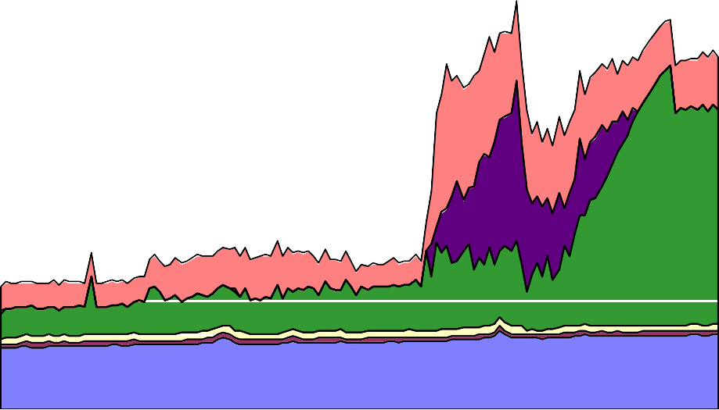

Other liabilities

£ billions

300

Short-term open market operations, drain Reserve Balances

Foreign currency public securities issued Cash ratio deposits

Notes in circulation

**Lehman**

**APF Phase II**

250

200

150

100

50

0

Mar-07 Jun-07 Sep-07 Dec-07 Mar-08 Jun-08 Sep-08 Dec-08 Mar-09 Jun-09 Sep-09

£ billions

Other liabilities

300

Short-term open market operations, drain **Lehman APF Phase II**

Reserve Balances

250

Foreign currency public securities issued

Cash ratio deposits

Notes in circulation 200

150

100

50

0

Mar-07 Jun-07 Sep-07 Dec-07 Mar-08 Jun-08 Sep-08 Dec-08 Mar-09 Jun-09 Sep-09

**Assets**

£ billions

Other assets **Lehman APF Phase II** 300

Loan to APF

Longer-term sterling reverse repo 250

Short-term open market operations, lending

Ways and Means advances to HM Government 200

Bonds and other securities acquired via market transactions

150

100

50

0

Mar-07 Jun-07 Sep-07 Dec-07 Mar-08 Jun-08 Sep-08 Dec-08 Mar-09 Jun-09 Sep-09

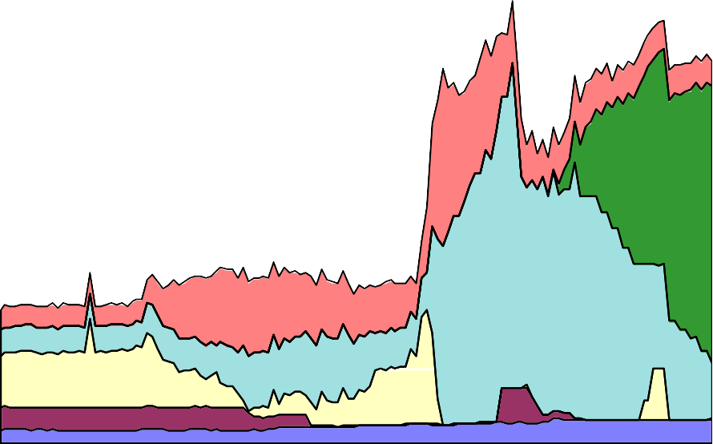

£ billions

Other assets

**Lehman APF Phase II**

300

Loan to APF

Longer-term sterling reverse repo

250

Short-term open market operations, lending

Ways and Means advances to HM Government

200

Bonds and other securities acquired via market transactions

150

100

50

0

Mar-07 Jun-07 Sep-07 Dec-07 Mar-08 Jun-08 Sep-08 Dec-08 Mar-09 Jun-09 Sep-09

# Chart 2 – Gilt yields

6

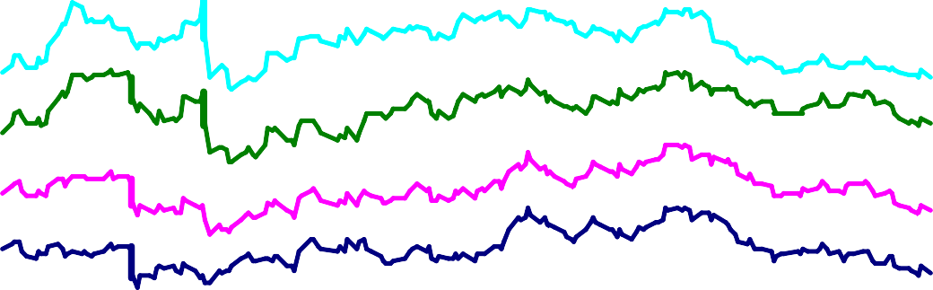

Feb IR

Pub.

March

MPC

May

MPC

August

MPC

per cent

20-year

10-year

5-year

3-year

5

4

3

2

1

0

Jan Apr Jul Oct 2009

Chart 3 – Gilt-OIS spreads a,b

basis points

40



US

Euro Area

UK

20

0

-20

-40

-60

-80

Mar Jun Sep 2009

1. Changes in Gilt-OIS spread since 4 March 2009
2. 5 year maturity

# Chart 4 – Sterling investment grade corporate bond spreads a,b

## Basis points

800

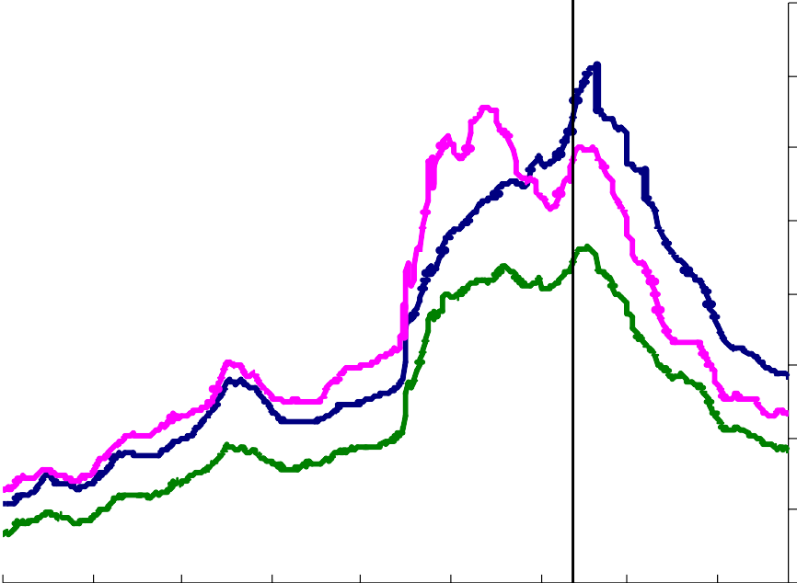

March

MPC

**Dollar**

**Sterling**

**Euro**

700

600

500

400

300

200

100

Aug Nov Feb May Aug Nov Feb 2007 08 09

0

## May Aug

1. Option adjusted spread over government rates
2. Rated BBB3 or higher

# Chart 5 – UK equity prices

4000

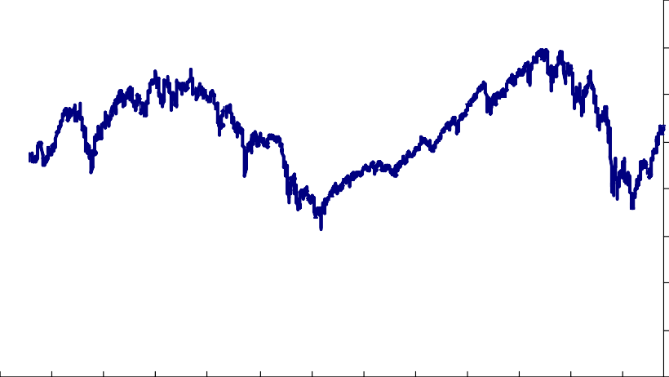

**FTSE All -Share**

3500

3000

2500

2000

1500

1000

500

0

1997 1998 1999 2000 2001 2002 2003 2004 2005 2006 2007 2008 2009

# Chart 6 – UK PNFC’s Cumulative equity and debt issuance

70

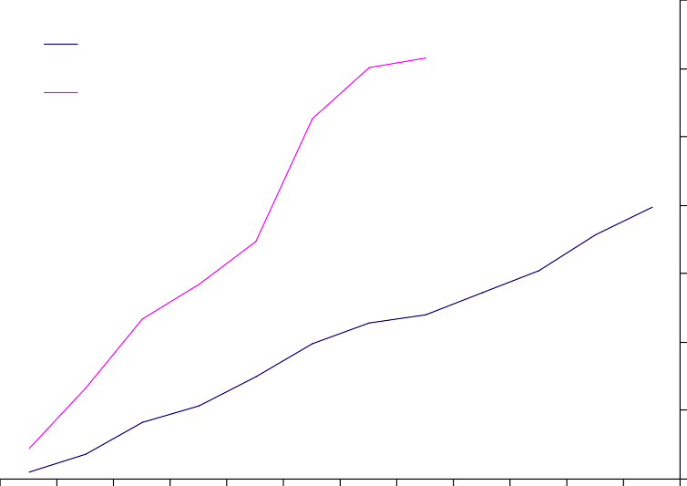

average 2003-2008

2009

60

50

40

£ bns

30

20

10

0

Jan Feb Mar Apr May Jun Jul Aug Sep Oct Nov Dec

# Chart 7 – International 3-month LIBOR-OIS spreads

Basis points

400

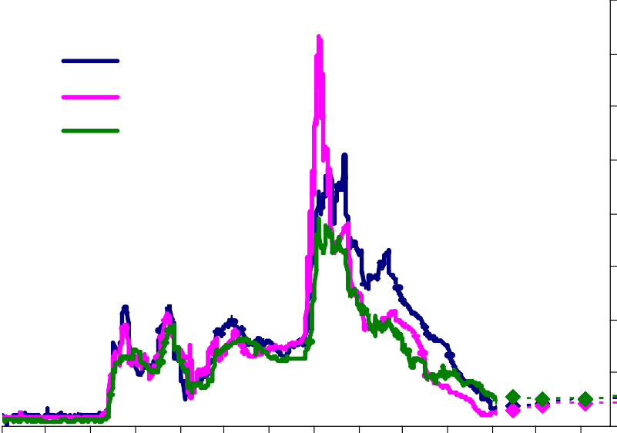

Sterling

US dollar Euro

350

300

250

200

150

100

50

0

Jan Apr Jul Oct Jan Apr Jul Oct Jan Apr Jul Oct Jan Apr

2007 08 09 10

# Chart 8 – Nominal GDP and broad money growth

percentage changes oya

20

M4-Intermediate OFCs

GDP

15

10

5

0

-5

-10

1987 1989 1991 1993 1995 1997 1999 2001 2003 2005 2007 2009